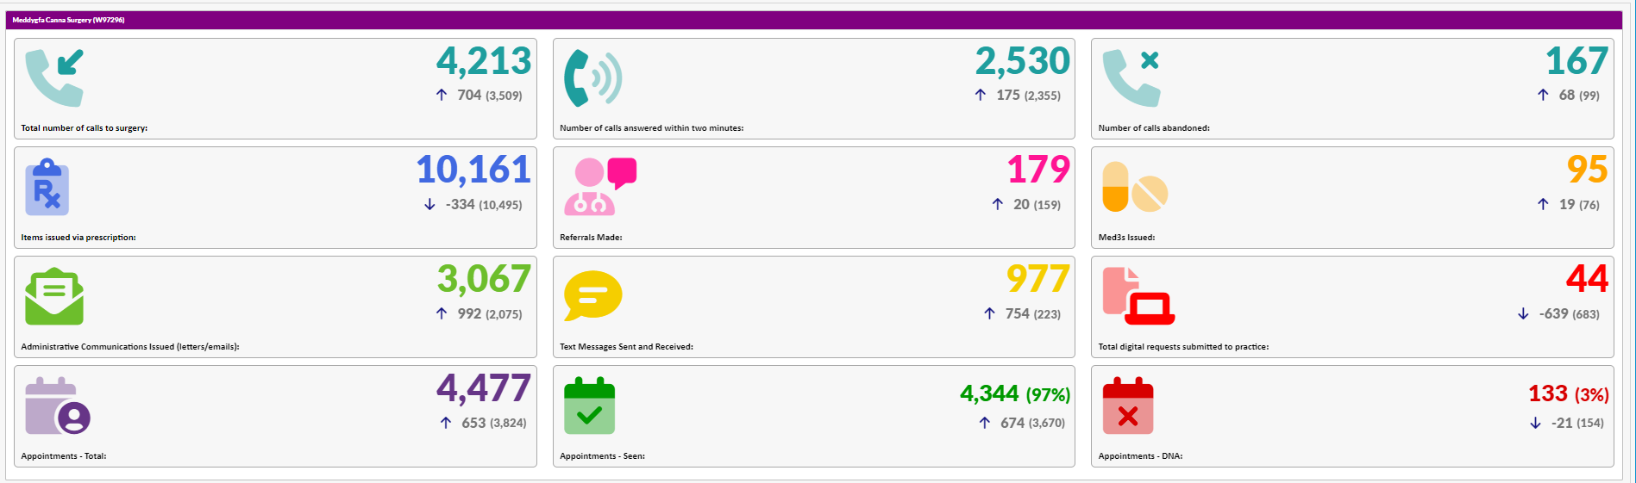

Meddygfa Canna Surgery
September 2022 Activity Data

